**Iteration Two**

**Louisville Office of Research and Innovation**

**Written by**

**Cardinal Strategic Development Team**

**Daniel Harbin**

**Queena Lin**

**Isaac Mills**

**Hasan Mohammad**

**Trey Sledge**

**Durian Spagnuolo**

**Dean Stitt**



**Table of Contents**

**Vision Document Page 3**

**System Requirement Page 14**

**Use Cases Page 16**

**Architecture Consideration Page 21**

**Risk Analysis Page 23**

**Gantt Chart Page 25**

**Prototype Page 26**

**UofL Research & Innovation Project**

**Vision Document**

**Version <2.0>**

**Daniel Harbin**

**Queena Lin**

**Isaac Mills**

**Hasan Mohammad**

**Trey Sledge**

**Durian Spagnuolo**

**Dean Stitt**

**Revision History**

|  |  |  |  |
| --- | --- | --- | --- |
| **Date** | **Version** | **Description** | **Author** |
| 01/23/2020 | 1.0 | Basic inputs | CSDG |
| 02/13/2020 | 1.1 | Feasibility Additions | CSDG |
|  |  |  |  |
|  |  |  |  |

|  |  |
| --- | --- |
| The Cardinal Research Web Improvement Project | Version: <1.1> |
| Vision Document | Date: <01/30/2020> |
| <document identifier> | |

**Table of Contents**

1. Introduction 6

1.1 References 6

2. Positioning 6 2.1 Problem Statement 6

2.2 Product Position Statement 6

3. Stakeholder and User Descriptions 7

3.1 Stakeholder Summary 7

3.2 User Summary 7

3.3 User Environment 7

3.4 Summary of Key Stakeholder or User Needs 8

3.5 Alternatives and Competition 9

4. Product Overview 9

4.1 Product Perspective 9

4.2 Assumptions and Dependencies 9

5. Product Features 9

6. Other Product Requirements 10

7. Appendix A 10

7.1 Feasibility Considerations Overview 10

7.2 Technical Feasibility 11

7.3 Organizational Feasibility 11

7.4 Economic Feasibility 12

7.5 Itemized Cost Sheet 12

**Vision Document**

# **Introductio****n**

This document will define the scope of the project, identifying the current shortfalls of the processes. The targeted users are Industry, Students, Researchers, and Community. The project focuses on the needs of the stakeholders addressing the users that should be drawn to the site.

## **Reference****s**

1. Vision Document Template
2. “Higher Education Research and Development Survey Fiscal Year 2018”, <https://ncsesdata.nsf.gov/herd/2018/index.html> accessed on Jan 29, 2020
3. “University of Louisville Research and Innovation*”,*<https://louisville.edu/research>, accessed on Jan 28, 2020
4. “The University of Louisville Research and Innovation Metrics FY 2020 July-Sept”, PDF, <https://louisville.edu/research/metrics/uofl-research-innovation-metrics>, accessed on Jan 29, 2020

# **Positioning**

## **Problem Statement**

|  |  |
| --- | --- |
| The problem of | The client’s current website is inefficient. |
| are | Student, Researcher, Community members, Industry, and Administrator within Louisville |
| the impact of which is | The impact is potentially lost revenue. A more efficient web system will capitalize on research demands. |
| a successful solution would be | A website that is aspires different stakeholders to collaborate with the University |

## **Product Position Statement**

|  |  |
| --- | --- |
| For | The target customers are companies, industry members, and individual researchers seeking cutting-edge resources. |
| Who | seeking opportunities to increase revenue and to obtain funds |
| The (product name) | UofL Office of Research and Innovation Website |
| That | showed potentials to attract industries and business to conduct more research |
| Unlike | complex and confusing research facilities |
| Our product | is a well-designed structure that is ease of access, and easy navigations |

# **Stakeholder and User Descriptions**

## **Stakeholder Summary**

|  |  |  |
| --- | --- | --- |
| **Name** | **Description** | **Responsibilities** |
| University of Louisville  Government (State and Federal) | This stakeholder is the parent company of the client.  This stakeholder is an issuer of monetary awards. | Help maintain the project’s process.  approves fundings and federal grants to the University |

## **User Summary**

|  |  |  |  |
| --- | --- | --- | --- |
| ***Name*** | ***Description*** | ***Responsibilities*** | ***Stakeholder*** |
| Researcher  Student  Community  Industry | Innovators of different research topics  Louisville students who participated in research projects  Involved members of the Louisville community  Business corporations from different field | Produces analytical reports and data analysis of research  Participate in research activity and expanding their knowledge  addresses concerns and hosting community services  provides partnership programs and additional funding for the university | Themselves  Themselves  Themselves  Themselves |

## **User Environment**

Currently, there are 7 members involved in the team to recreate a well-designed website for UofL Research and Innovation with the goal to increase the University’s revenue. Currently, this task is still in its proposal phase with multiple competitions among different groups. The expected task cycle will take approximately four-month followed by another four-month starting next semester. There are no expected changes to this process unless an unexpected event occurs such as natural disaster prevents us from completing the project.

The University of Louisville uses IRIS which is a research platform for its student, researcher, and the whole community. We are also planning to keep our content management system and payment management system without changes. This means that there will be a low compatibility issue with the platform.

The System platform that is in use currently is Plone. It is an Open Source CMS with limitless Extensibility, Scalability, integration with specialized applications and standard enterprise systems, and many more features.

The system should have the ability to give live updates of the UofL Research and Innovation twitter feed to help the Community know what the university is currently doing.

The system should be easily usable by all users by providing a good search interface to help the user reach their end goal.

The system should be able to help all users understand individual activities that they can participate in.

## **Summary of Key Stakeholder or User Needs**

The website has several problems that need to be addressed. The linking of pages on the main page is organized without a distinction of which subgroup they are addressing. The tabs that are at the top of the page are missing direct paths to the information that is held in the subcategories. The industry has information that is given in several different tabs, an innovation that is available to the industry is not in the main topic. Spotlighting innovation within the top of the website will ensure full visibility of new opportunities available. Creating a specific tab that groups all information to Industry in one place will ensure full visibility.

The second problem with the website is community information. The same issues are found in the information for the community as above, the spread of information with no central location. Information about success stories shown but easily missed, the webpage should attract users to certain areas. Community users must engage the webpage through several tabs to find specific information. The resolution would be to use images or effects within the webpage to highlight the success stories and give a central location to get additional information.

The third problem with the website is the Researcher information, in addition to the above information is given in all areas of the website. The tabs throughout the website enable Researchers to pursue links to the wrong information. The webpage is not only missing a central location but also specifics to which research the tab holds. The resolution would be to break the research into subcategories based on the field of study and provide options within an additional web page that is user-specific.

The last problem incorporates two major factors Students and Administrators, the information for both are lacking in information. The links give the user insight into where to go to find information but lack innovative design. The whole website is standardized, overall impression of the website shows that little to no effort was used in the creation. Incorporating new designs that enhance the overall look of the webpage and spotlighting new or current initiatives will give insight to new users. Improving design to attract new users attention to main items and simplifying resource links will improve user experience. The goal of making improvements is to showcase initiatives and improve user navigation. The outcome for a supported website would be to increase user traffic by enabling users to navigate the site quickly and increase proposals by showcasing current/past engagements.

The original design of the website consisted of problems such as low visibility, overwhelming information, unclear processes, dated designs, and unclear incentives. This makes the stakeholders such as students, researchers, industry, administrators, and community to be able to find the information that they need quickly. Most information is mixed and the stakeholders find it difficult to find what they need. The main goal for this project is to improve the general design of the website. By re-innovating the website’s design, our biggest goal is to re-organize all the business processes to make it more clear and easy to understand.

|  |  |  |  |  |  |
| --- | --- | --- | --- | --- | --- |
| Need | Priority | Concerns | Current Solution | Proposed Solutions | |
| Reconstruct the website of the Office of Research and Innovation to improve the effectiveness for access of information for stakeholders | High | Stakeholders are unable to find correct information | None | | gtggg Create new tabs that differentiate information for different access group |

## **Alternatives and Competition**

The competition includes the University of Kentucky and different offices of research and innovation in Kentucky that may prevent our website from gaining patrons. Since the University of Kentucky is also an organization that is located in Kentucky, they are the top competitor against the University of Louisville. Its major strength is it showed a clear display of the research processes with data, resources, and core research priorities, however, they lack processes which can link them to funding or connect them with their students.

# **Product Overview**

## **Product Perspective**

This product is affiliated with the University of Louisville. The university helped develop research goals, policies, and procedures and also provide and oversight of activities, scholarships, and for the development of the research ideas. The Office of Research and Innovation is responsible for all the research-related portions of the university and accepts proposals from multiple departments such as business, speed school, arts & science, medicine, school of law, etc. The university serves as a measure to provide this product resources and funding for its stakeholders. This product also stimulates the partnerships of the business industry and the Louisville community.

## **Assumptions and Dependencies**

* Changing payment systems could make certain cards become incompatible resulting in a loss of donations
* A change in emphasis from one of the main points (student, industry, community, researchers) to another point(s). such a change would alter the entire vision of the web page going forward
* The mobile market is large if we were planning support for one browser, but the consumer browser of choice changes to one we did not support we could lose potential funding
* If we were expecting our customers to use one browser and they choose a different, non-supported browser, it could affect formatting, usability, and readability
* News and announcements are all dependent on people consistently updating them, if they are not updated properly users could miss important information
* Security is an important topic if we are expecting to attain a particular level of security but we cannot meet the standard we are putting our user’s information at risk
* Error handling is all dependent on errors being identified and fixed on the back end, if we cannot identify an error before an end-user experience it we could lose funding opportunities

<https://ncsesdata.nsf.gov/herd/2018/html/herd18-dt-tab005.html>

# **Product Features**

* Easy navigation for the user’s convenience
* Trendy, updated visual design to attract new users
* Contrasting color scheme, including brand colors, to make it easy on the user’s eyes
* Relevant content to keep the website fresh
* Visible links for iRIS, social media, and other portals
* News and announcements
* Events
* Link to donate for users that want to make quick contributions
* Tab for students (undergraduate and graduate)
* Tab for industry members
* Tab for community members
* Tab for centers & institutes broken up into subcategories that are easy for the user to understand
* Mobile compatibility so users can have access on-the-go
* Information architecture to integrate users, content, and context
* Formatted content to make scanning easy
* Error handling so users do not have to experience bugs from the code-level
* Usable, interactive forms to avoid off-site requirements
* Security so user data is safe
* Interactivity area for communication between the main audiences
* Increased searchability for web searching
* Easily accessible contact information for expedence
* The coherent vibe as the user moves between the audiences
* Footer features for popular links
* Frequently asked questions
* Infographics to easily explain complicated ideas

# **Other Product Requirements**

* Software/web integration requirements
* Email EVPRI service account (newsletter)
* Forms
* Compliance and Policies
* Preservation of required links (iRIS)
* Louisville Brand Standards
* Coherent Navigation and Organization of content
* Search Bar
* Contact Information
* Correct terminology for expressing specific content

# **7. Feasibility**

**7.1Feasibility Considerations Overview**

This is an overview of the feasibility considerations and associated risks considerations split into three areas: Technical (Can We Build It? ), Organizational (will They Use It?) and Economic (Is It Worth It?). In the Technical feasibility study the focus is subdivided into Functional Area (Is the project group familiar with the system), Technology ( Is the project group familiar with the technology that must be implemented) and Project size. The Economic Feasibility focus is subdivided into two subsections. Preliminary cost analysis and revenue projection.

**7.2 Technical Feasibility**

**7.2a.Functional Area**

Risk increases dramatically when the users themselves are less familiar with an application, such as with the development of a system to support business innovation. The current member-facing (front end) of the website has tabs coordinated to different locations that are not inherently difficult to reconstruct. The current tabs can be repurposed and web links to refer to Industry-specific material. The effort to complete this task is moderate and within the skill set of the current team. As the website is the University of Louisville website and the makeup of the team are current students of the university. Thus, this project has a low risk in this respect as we are very familiar with its use.

**7.2b.Technology**

When a system uses technology that has not been used before within the organization, there is a greater chance that problems will occur, and delays will be incurred because of the need to learn how to use the technology. Risk increases dramatically when the technology itself is new. Due to the parameters and scope of the project, we will not be changing any major systems involved in the website such as the content management system or payment management system. There are no foreseeable compatibility issues. Thus, there is a low technical risk.

**7.2c.Project Size**

As with any project of this magnitude, project size is an important consideration, whether measured as the number of people on the development team, the length of time it will take to complete the project or the number of distinct features in the system. Larger projects present more risk, both because they are more complicated to manage and because there is a greater chance that important system requirements will be overlooked or misunderstood. The extent to which the project is highly integrated with other systems can cause problems because complexity increases when many systems must work together. The systems in use are highly integrated within the organization and thus generates a low level of risk. The development team is newly formed, and its large size generates a moderate level of risk.

**7.3.Organizational Feasibility**

The organizational feasibility of the system, how well the system ultimately will be accepted by its users and incorporated into the ongoing operations of the organization is a necessary issue to be considered. There are many organizational factors that can influence the project, and seasoned developers know that organizational feasibility can be the most difficult feasibility dimension to assess.

**7.3a.Strategic Alignment**

In the words of the Vice President of the Office of Research and Innovation “At the University of Louisville, we apply that methodology to the ideas that come out of our research. Rather than keep them in the classroom or lab, we use those ideas as a mash that we ferment, double and age into products, companies, and partnerships — each with a potential human, the societal and economic impact that reaches far beyond our campus.” In terms of strategic alignment, there is a low-level risk. Our project is fully in line with the strategic goals of the organization. This project will renovate the face of the organization i.e. its website, to fit its mission and goals. The project will reorganize and update the processes conducted on the website in order to better facilitate the mission of the organization. The current process is not easily accessible to the user causing possibly a loss of funds for students and researchers, potential industry partners and useful and meaningful relationships to the community. The emphasis of the project will focus its students, researchers, industry, and community as its primary stakeholders.

**7.4. Economic Feasibility**

**7.4a. Cost-Analysis**

The cost of making the necessary changes is relatively low. We split costs into two categories: development costs and annual costs. Development costs occur only in year zero, of the five-year project. The development costs are:

* Hardware
* Software
* Operation labor

The annual costs occur in years one through five and grow at the current rate of inflation. The annual costs are:

* Consumables
* SQL Server
* PMS Update and Support
* Firewall Support

**7.4b. Projections**

In the fiscal year 2018, UofL ranked 125th in Research and Development (R+D) expenditures at $176.5m. The five schools ranked ahead of UofL (Nebraska Medical, Houston, Texas Medical, West Virginia, and Texas Tech) averaged $181.5m in R+D expenditures. The ten schools ahead of UofL (previous five-plus Delaware, Oklahoma State, Wake Forest, Tulane, and Florida International) averaged $186.3m. FY 2019, Grant & contract awards to our nearest in-state rival, the University of Kentucky totaled $417.1 million. That’s nearly three times the amount the University of Louisville received.

For the year 2017, UofL received 931 awards on 1296 proposals. That is a total of $147.8M in awards. That’s an average of $158,758 per award. For the year of 2018, UofL received 914 awards on 1109 proposals. That is a total of $137.9M in awards received. That’s an average of $150,872 per award. For the year of 2019, UofL received 950 awards on 1087 proposals. A total of $152.1M in awards received. That’s an average of $160,067 per award. Though the overall amount of awards increased over a three year period. UofL saw a steady decline in proposals over the same time frame. The 3-year average is $156,566 per award.

We based our targets on the notion that if UofL increases the total amount of proposals per year there would be a correlating increase in the amount of award money per year. Our pessimistic target is an increase in the number of awards by 5 for an estimated increase of $782,828. Our optimistic target is an increase in the number of awards by 15 with the new system for an estimated increase of $2,348,483. Our realistic target is an increase of 10 more awards for an overall estimated increase of $1,565,655. per year. If UofL takes 40%, that is an increase of $626,262 in revenue.

**7.5 Itemized Cost Sheet**

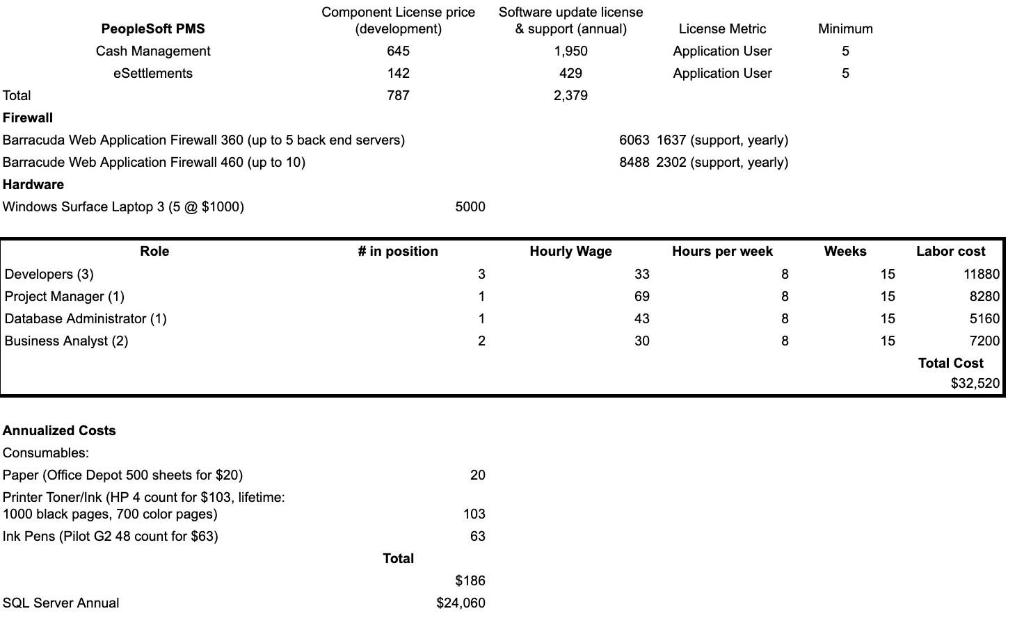

**Fig. 1.1** This sheet breaks all costs into annual or developmental. The labor costs all occur in year zero and are based on a team of 7 team members.

**7.5b Pessimistic Target**

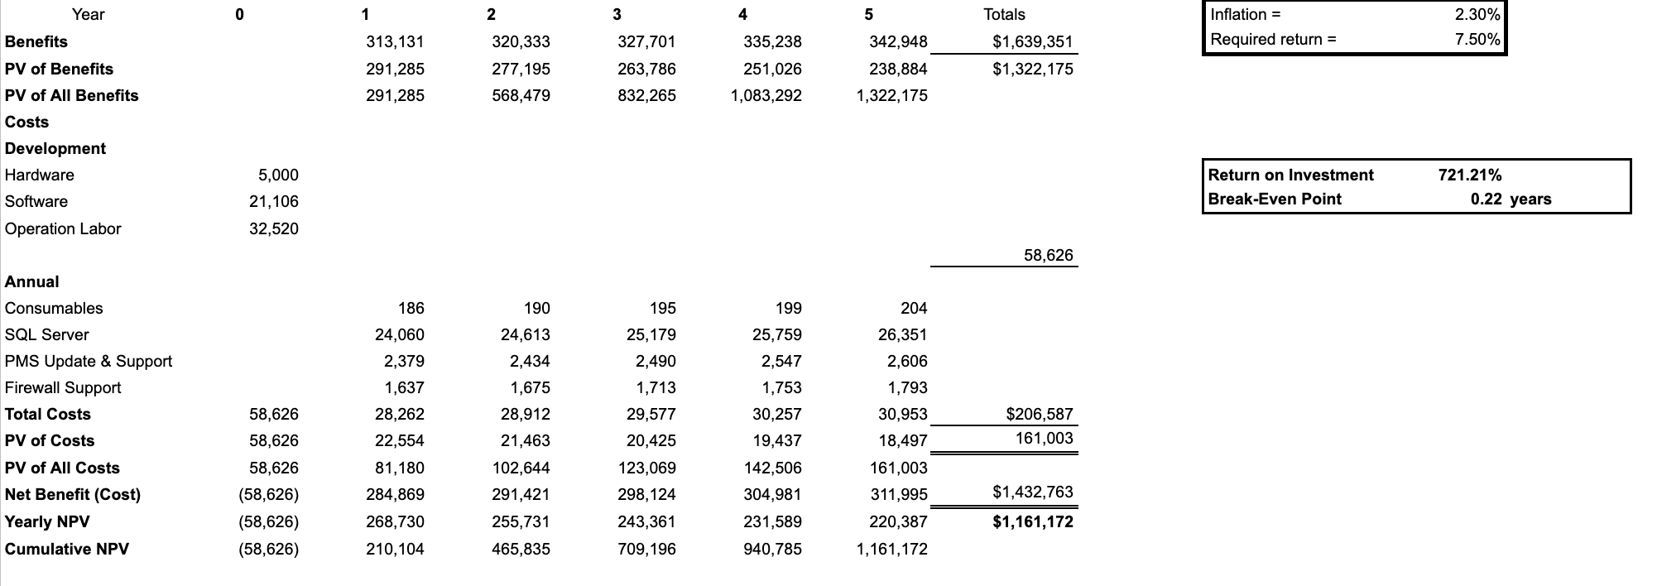

**Fig. 1.2** This is the project’s floor. At our low projection we can still expect to recover the investment in the first quarter of year one. The return on investment is over 700% and it has a strong, positive NPV.

**7.5c Realistic Target**

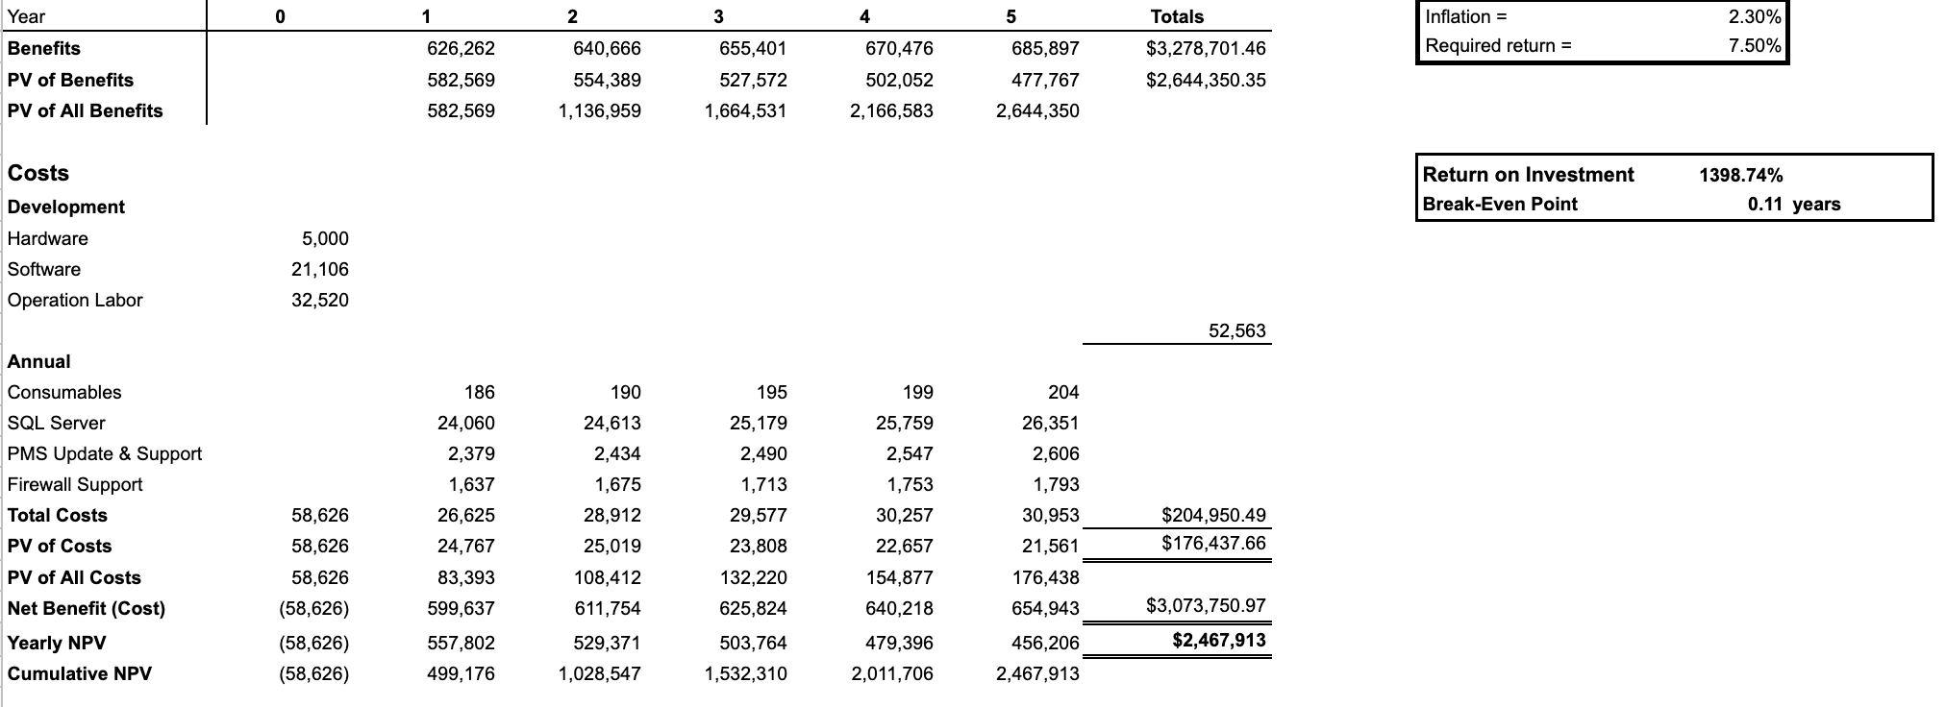

**Fig. 1.3** This is the actual forecast. The return on investment is almost 1400% and expect to break even in the second month of year one (could potentially break even with a single grant awarded).

**7.6c Optimistic Target**

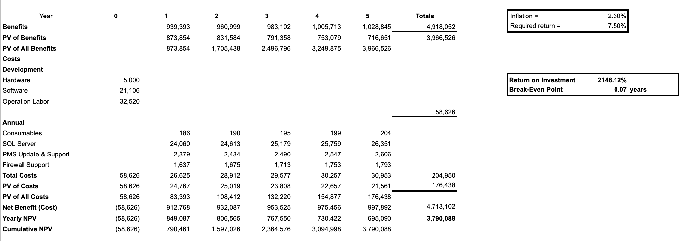

**Fig. 1.4** This is our optimistic target. If the system performs better than expected, we will see over a 2100% return on investment. This will cover the initial investment in the first month after rolling out the system.

**System Requirements**

*Functional*: relates directly to a process a system has to perform or the information it needs to contain. Flow directly into the creation of functional, structural, and behavioral models that represent the functionality of the evolving system.

Ex: requirements that state that a system must have the ability to search for available inventory or to report actual and budgeted expenses.

**WHAT BEHAVIOR THE SYSTEM SHOULD OFFER**

*Nonfunctional*: refer to behavioral properties that the system must have, such as performance and usability. The ability to access the system using a Web browser is considered a nonfunctional requirement.

Primarily used in design when decisions are made about the user interface, hardware & software, and the system’s underlying physical architecture.

It can influence the rest of the analysis but only indirectly.

**A SPECIFIC PROPERTY OR CONSTRAINT ON THE SYSTEM**

**Functional:**

1. The system will have applications for Industry Partners.
2. The system will have a(n) system for processing/Accepting grants.
3. The system will have a system for users to manage awards.
4. The system will have a system for donations.
5. The system will have a(n) system for researchers to manage projects (iRIS).
6. The system will have a(n) Social media for R&I to interact with the community.
7. The system will have a link to the newsletter via the University of Louisville magazine.
8. The system will allow Administrators to track performance.
9. The system will have a(n) area for current invitations R&I is working on.
10. The system will have a(n) Centers and Institutes page for navigation.
11. The system will have individual pages for each Stakeholder (Student, researcher, Industry, Admin, Community).
12. The system will have support for industry (industry request form).
13. The system will have event opportunities for the local community to engage.
14. The system will have scholarship opportunities for undergraduate students.
15. The system will have a student(undergraduate/Graduate research proposal form)
16. The system will have Licensing Collaboration Forms
17. The system will have Startup Partnership/Collaboration Forms
18. The system will have accessible forms for Graduate students for funding opportunities (internal and external).
19. The system will have accessible forms for Undergraduate students to find funding opportunities (internal and external).
20. The system will allow administrators to track current Projects
21. The system will allow administrators to maintain industry and community contacts list
22. The system will allow for collaborative efforts within the University of Louisville’s different centers and institutes
23. The system will have a sign-up form for the community.
24. The system will integrate current security measures provided by University of Louisville
25. The system will have good news and funding newsletters Forms
26. The system will have a redesign landing page
27. The system will have Twitter news widget
28. The system will have a legal portal
29. The system will maintain current lead flows

**Non-Functional:**

1. The system will be secured by the University of Louisville’s firewall
2. The system will be user-friendly
3. The system will have a near-perfect uptime
4. The system will use Plone as the Content Management System
5. The system will use PeopleSoft as the Payment Management System
6. The system will use Microsoft SQL Server 2016 as a Database Management System
7. The system will have back-up capabilities
8. The system will have desktop capabilities
9. The system will have mobile capabilities (access from any device)
10. The system will follow the universities guidelines
11. The system will incorporate security guidelines and policies

**Use Cases**

This section will cover the use cases found in the functional requirements. All use cases are specific to the function that they provide to the users. Use case names are used to identify the case that is to be discussed in the use case. The primary actors are used to determine the user that will be actively using the use case. Within the description you will find information defining the use case in detail, and how the use case will be used by the actor. The ID will define the location of the use case within the document, this is only used as the identifying factor. Use cases will be listed below, containing all above information with standardized template format.

|  |  |
| --- | --- |
| **Use Case Name:** Open applications for Industry | **ID:** 01 |
| **Primary Actor(s):** Industry | |
| **Brief Description:** This use case will enable users to open applications. | |

|  |  |
| --- | --- |
| **Use Case Name:** Process / accept grants | **ID:** 02 |
| **Primary Actor(s):** Students, Industry, Administrators, and Community | |
| **Brief Description:** This use case will give users the ability to process grants, and administrators ability to approve them. | |

|  |  |
| --- | --- |
| **Use Case Name:** Manage awards by users | **ID:** 03 |
| **Primary Actor(s):** Administrators | |
| **Brief Description:** This use case will give administrators ability to manage awards | |

|  |  |
| --- | --- |
| **Use Case Name:** Access to the donation system | **ID:** 04 |
| **Primary Actor(s):** Students, Industry, and Community | |
| **Brief Description:** This use case will give users the ability to access the donation system. | |

|  |  |
| --- | --- |
| **Use Case Name:** Access to the system for researchers to manage projects (iRIS) | **ID:** 05 |
| **Primary Actor(s):** Researchers, students | |
| **Brief Description:** This use case will give users the ability to manage current projects. | |

|  |  |
| --- | --- |
| **Use Case Name:** Interact with the community via social media for R&I | **ID:** 06 |
| **Primary Actor(s):** Community | |
| **Brief Description:** This use case will give users the ability to interact with the community. | |

|  |  |
| --- | --- |
| **Use Case Name:** Clickable link to the newsletter via the University of Louisville magazine | **ID:** 07 |
| **Primary Actor(s):** Students, Industry, Researcher and Community | |
| **Brief Description:** This use case will give users the ability to access the newsletter. | |

|  |  |
| --- | --- |
| **Use Case Name:**  Track performance for administrators. | **ID:** 08 |
| **Primary Actor(s):** Administrator | |
| **Brief Description:** This use case will give administrators the ability to track the performance of the site. | |

|  |  |
| --- | --- |
| **Use Case Name:** Viewing area for current invitations R&I is working on. | **ID:** 09 |
| **Primary Actor(s):** Students, Industry, Researcher and Community | |
| **Brief Description:** This use case will give users the ability to interact with current invitations. | |

|  |  |
| --- | --- |
| **Use Case Name:**  Viewing page for Centers and Institute’s navigation. | **ID:** 10 |
| **Primary Actor(s):** Students, Industry, Researcher and Community | |
| **Brief Description:** This use case will give users the ability to view and navigate the main page. | |

|  |  |
| --- | --- |
| **Use Case Name:** Clickable individual pages for each Stakeholder (Student, researcher, Industry, Admin, Community) | **ID:** 11 |
| **Primary Actor(s):** Students, Industry, Researcher, Admin, and Community | |
| **Brief Description:** This use case will give users the ability to separate content and navigate to content as needed. | |

|  |  |
| --- | --- |
| **Use Case Name:** Viewable/clickable form for support for industry (industry request form) | **ID:** 12 |
| **Primary Actor(s):** Industry | |
| **Brief Description:** This use case will give users the ability to view and navigate to industry form. | |

|  |  |
| --- | --- |
| **Use Case Name:** Viewable event opportunities for the local community to engage. | **ID:** 13 |
| **Primary Actor(s):** Students, and Community | |
| **Brief Description:** This use case will give users the ability to view and join events. | |

|  |  |
| --- | --- |
| **Use Case Name:**  Viewable scholarship opportunities for Students. | **ID:** 14 |
| **Primary Actor(s):** Students | |
| **Brief Description:** This use case will give users the ability to apply and view scholarships. | |

|  |  |
| --- | --- |
| **Use Case Name:** Accessible forms for Graduate students to find research and funding opportunities (internal and external). | **ID:** 15 |
| **Primary Actor(s):** Students | |
| **Brief Description:** This use case will give users the ability to apply and view scholarships. | |

|  |  |
| --- | --- |
| **Use Case Name:**  Accessible forms for Undergraduate students to find research and funding opportunities (internal and external). | **ID:** 16 |
| **Primary Actor(s):** Students | |
| **Brief Description:** This use case will give users the ability to find research and funding opportunities. | |

|  |  |
| --- | --- |
| **Use Case Name:** Allow administrators to track current Projects | **ID:** 17 |
| **Primary Actor(s):** Administrators | |
| **Brief Description:** This use case will give users the ability to track current projects. | |

|  |  |
| --- | --- |
| **Use Case Name:**  Editable form for collaborative efforts within the University of Louisville’s different centers and institutes. | **ID:** 18 |
| **Primary Actor(s):** Students, Industry, and Community | |
| **Brief Description:** This use case will give users the ability to edit and view collaborative parts of the site. | |

|  |  |
| --- | --- |
| **Use Case Name:**  Undergraduate students funding opportunities | **ID:** 19 |
| **Primary Actor(s):** Students, Industry, and Community | |
| **Brief Description:** This use case will give users the ability to fund opportunities for undergraduates. | |

**Architectural Considerations**

**Brief:**

The major architectural components of any system are the software and the hardware. The major software components of the system are identified and then allocated to the various hardware components on which the system will operate. All software systems can be divided into four basic functions. These four functions (data storage, data access logic, application logic, and presentation logic) are the basic building blocks of any application. In our design Microsoft SQL Server 2016 will act as a Database Management System and Plone will act as Content Management System. The three primary hardware components of a system are client computers, servers, and the network that connects them. Client computers are the input/output devices employed by the user and are usually desktop, laptop computers, handheld devices, cell phones, special-purpose terminals, and so on. Servers are typically larger computers that are used to store software and hardware that can be accessed by anyone who has permission. Servers can come in several types: mainframes, minicomputers, and microcomputers. In our case, we will be using the servers already in use by the website. The network that connects the computers can vary in speed from a slow cell phone or modem connection that must be dialed, to medium-speed always-on frame relay networks, to fast always-on broadband connections such as cable. Lastly, security must be considered. Given the University of Louisville guidelines and policies, our design will integrate security and firewall suites provided by the University

**Narration:**

Users can connect to websites through multiple platforms. All Payment and Content Systems will reside behind the firewall in order to protect content and transactions. The Database system is also placed behind the firewall to better protect the database for injection attacks and protect confidential information.

**Design**

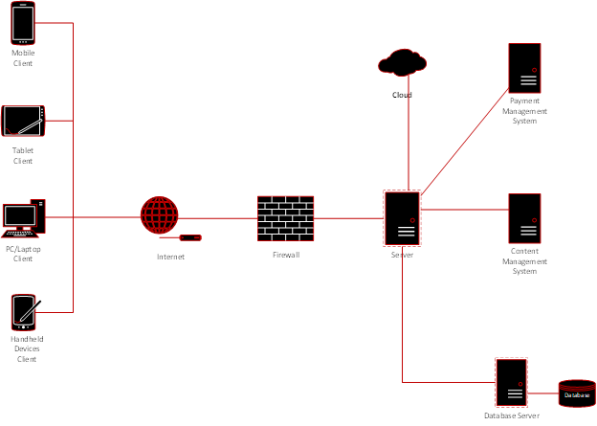

**Narration:**

This brief outline of the systems our group plans to implement in our design. PeopleSoft is the University of Louisville payment management system and is required by university policy to be implemented as the website’s payment management system. SQL server will manage internet servers and act as the database management system. Plone is the university’s content management system, this system controls all the content both incoming and outgoing. According to University policy, it is the required content management system for all university websites.The firewall and security suite provided by the university will be used to protect all pertinent servers. As it is confidential, we have termed it UofL Security Suite and Firewall. The cloud computing service used by the university is Cardbox and will be integrated into our design.

**Realization**.

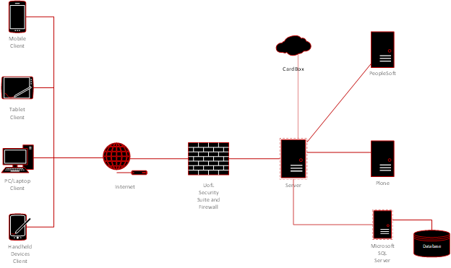

**Risk Analysis**

Risk analysis is the process of identifying and analyzing different factors of consideration that may impact a project or assessment. By determining the risk value of different use cases and architecture considerations, the high-risk item will be prioritized with detail and careful completion.

**Used Case Risk Analysis**

Case 1: **iRIS**

Risk level: High

Criteria: Only available for the researcher, administrators, students, and alumni. Non-UofL affiliated members are required to create an account using proper ID and validations.

* Allows submission and navigations of proposals

Method: Need to issue a login screen that can direct the users to iRIS

Case 2: **Funding**

Risk level: High

Criteria: Need the stakeholders such as student, administrator, and industry to go through the cost management system which provides the necessary information for budgeting and planning.

* Allows the administrator to access and manage grants and fundings from the federal and state government.
* Allows the request, denial, and approval of grants and funds for the community, students, and researchers

Method: Create Budgeting and Planning Portal

Case 3: **Contact us**

Risk level: Low

Criteria: Social media, phone, email

* Requires an official social media account from Facebook, Twitter, and Instagram that is able to inform users of major events and opportunities that the UofL Research and Innovation Office provides.
* Requires the University to provide emails and phone number that can link the users to a certain department in order to contact them

Method: Addition of social media widgets and create relevant contact pages for each stakeholder

Case 4: **Newsletters and announcement**

Risk level: Low

Criteria needed for newsletter include anyone who is interested in the research programs.

* We will need to ensure that the information is updated daily to make sure the students, researchers, and community members received the most current news.
* Engage the community members toward opportunities and events

Method: maintaining the information

**Technical Risk Analysis**

Case 1: **Account Privileges**

Risk level: High

Criteria: Requires that different stakeholders hold different levels of privileges on the website. This is mainly facilitated by the administrator.

Method: Students have access to current projects and researchers manage research through iRIS. Implement UofL Organizational Units and Create Group Policies

Case 2: **Privacy and Security**

Risk level: High

Criteria: Must make sure that all sensitive data and information are kept private.

Method: Integrate existent Firewall and Security Suite provided by UofL

Case 3: **Software integration**

Risk level: Low

Criteria: Requires that the website has no compatibility issues and is managed by the administrators.

Method: We will maintain content management system, payment management system, Database Management Systems i.e. Plone, PeopleSoft, Microsoft SQL Server 2016 respectively

Case 4: **Mobile/Tablet Platform**

Risk Level: Low

Criteria: Website needs to be Mobile and Tablet Friendly

Method: Design and Implement required coding

**Organization Risk Analysis**

Case 1: **Tracking Project and Performances**

Risk level: High

Criteria: Make sure that all projects and research are in the most current forms, ensuring that all major findings are updates.

Methods: Progress is saved while researches, students, industry, and administrators can track and manage current and future projects.

Case 2: **Accessible to forms**

Risk level: Low

Criteria: Requires all the forms in acceptable formats without compatibility issues. Must make sure all applications, either online or physical, accurately directs the users to the correct destination.

Methods: forms are accessible to all stakeholders

* Incorporated information for researches and internal/external funding opportunities

Case 3: **Legal**

Risk Level: Low

Criteria: Make sure all relevant stakeholders have access to legal resources provided by the Office Of Research and Innovations

Methods: Design and Link a Legal Guideline Portal

Project Gantt Chart (Iteration II - Iteration III)

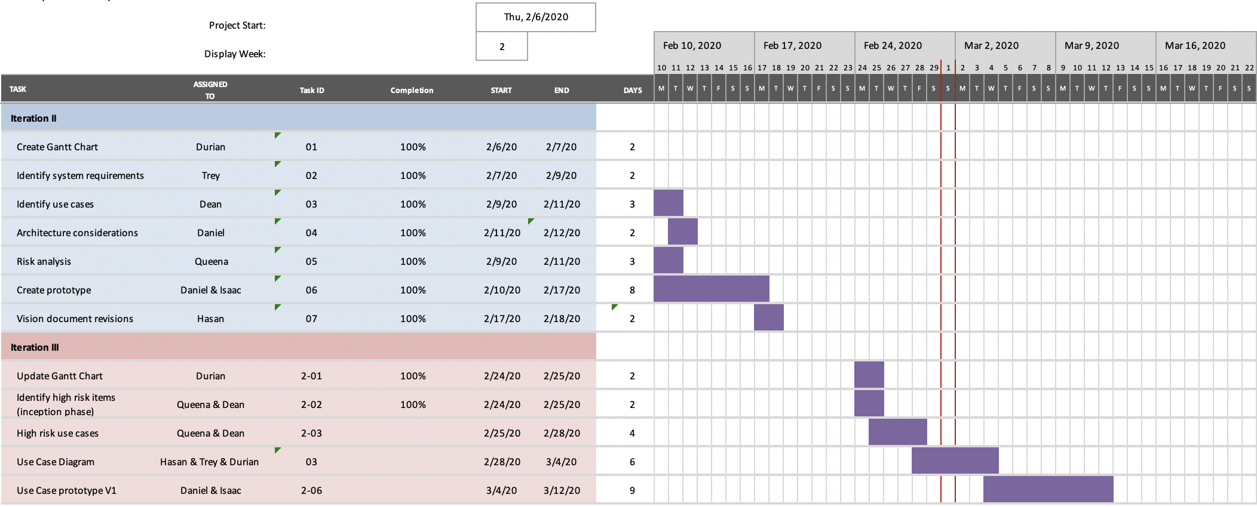

The Gantt chart details the project tasks from Iteration II through Iteration III. At this point in the project, Iteration II is complete and we are working towards Iteration III. On this schedule we will complete this iteration on March 12th.

Task dependencies:

* Task 2-03 is dependent on 2-02
* Task 2-06 is dependent on 03.

**Prototype - (landing page)**

**Narration:**

A website prototype is a mock-up of what a website could look like when it goes live. Within this prototype we focus solely on what is called a landing page. A landing page is the first page a visitor sees when entering a website. The main goal of any landing page is to provide the visitor with a call to action that increases conversions (converting them into one of the main audiences). After converting the visitor, the navigation optimization will prompt them away from the landing page and deeper into the site.

